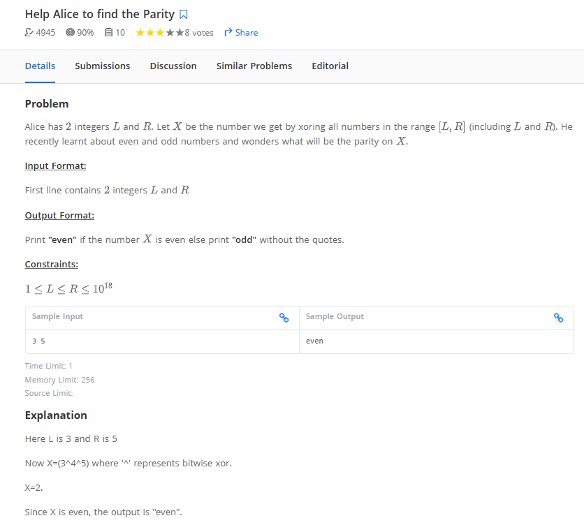

L ,R = map(int,input().split(' '))
#print(L)

# result = 0
# for i in range(L,R+1):
# result ^= i

# if result % 2 == 0:
# print('even')
# else:
# print('odd')

def xor_upto(n):
# Compute XOR from 0 to n using the pattern
if n % 4 == 0:
return n
elif n % 4 == 1:
return 1
elif n % 4 == 2:
return n + 1
else:
return 0

# XOR of numbers in range L to R
result = xor_upto(R) ^ xor_upto(L - 1)

if result % 2 == 0:
print('even')
else:
print('odd')

===========================

